Kunal Gupta – kg3163@nyu.edu

Franklin Yiu – fyy2003@nyu.edu

This image shows that the robot successfully stacked the second box on the first box and lifted up the final box 10cm (if you run the simulation you can see it can pull it up higher).

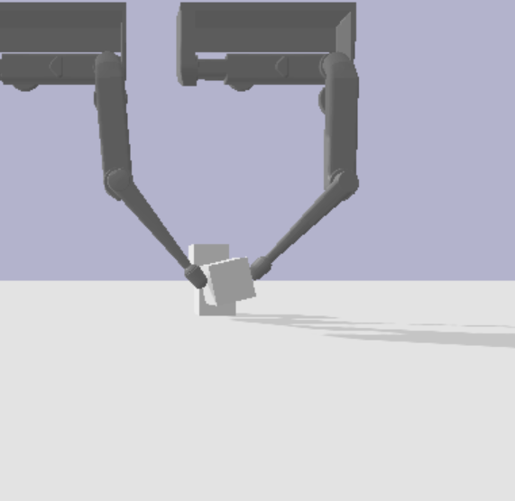

2d and 3d representations of Finger 1’s measured and desired position during the simulation:

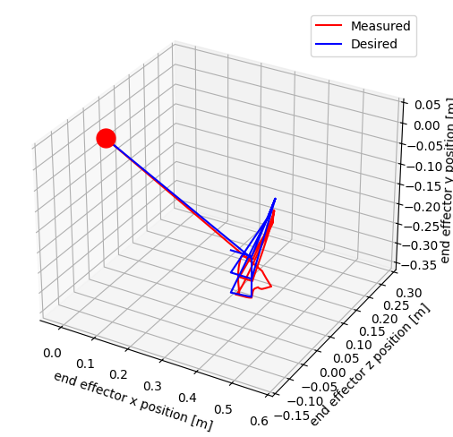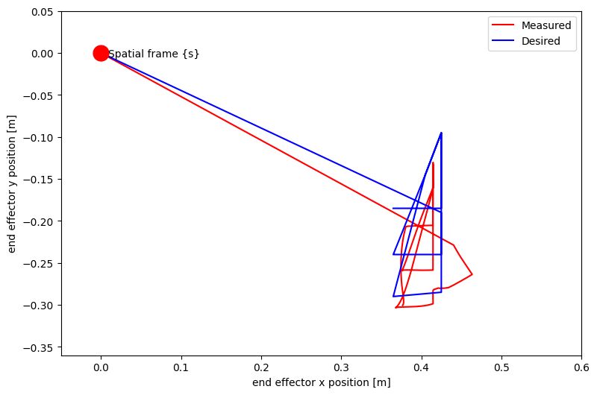

2d and 3d representations of Finger 1’s measured and desired position during the simulation:

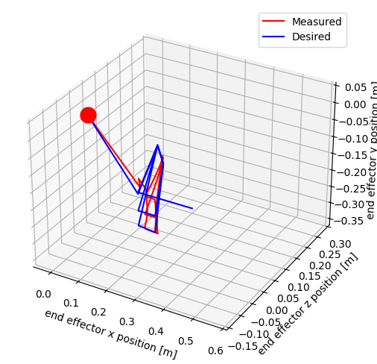

2d and 3d representations of Finger 1’s measured and desired velocity during the simulation (it is quite sporadic as it was fighting against gravity).

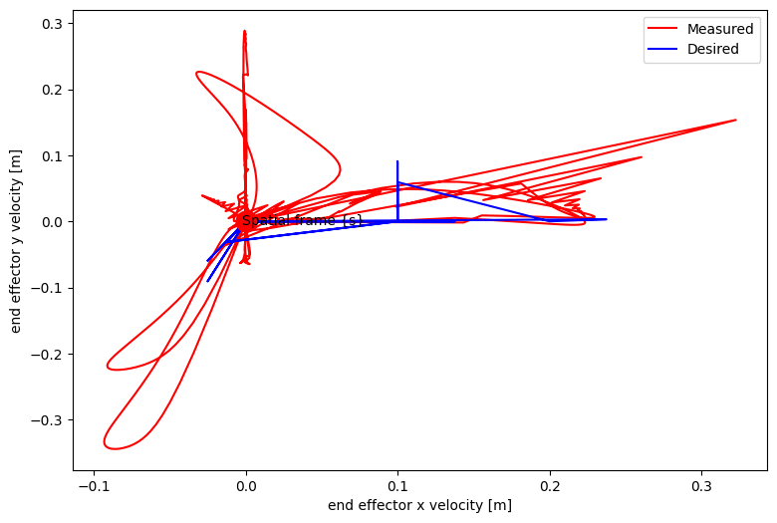

2d and 3d representations of Finger 1’s measured and desired velocity during the simulation (it is quite sporadic as it was fighting against gravity).

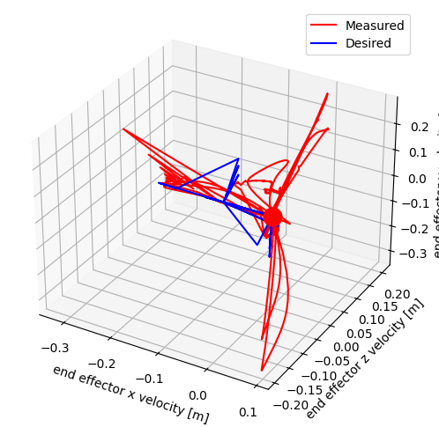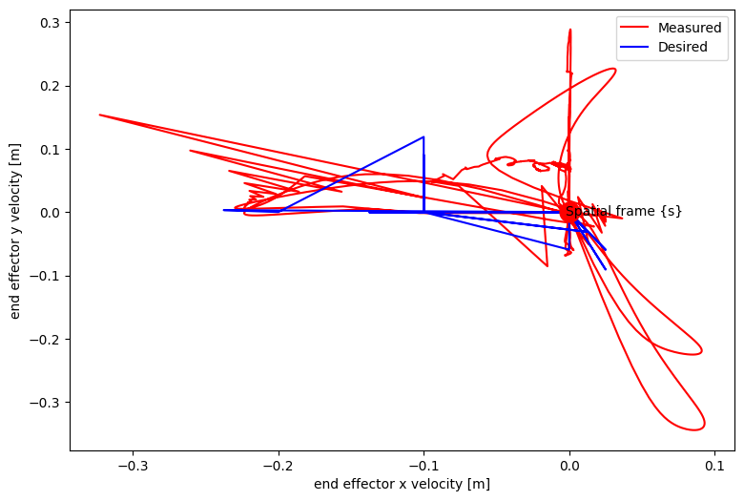

Q3:  
  
In the given robot control system, the current joint positions and velocities of the robots are first retrieved. The impedance control is then implemented where the desired end-effector positions and velocities are calculated based on a linear interpolation trajectory between the start position and the goal. Using the Jacobian of the robot and two control gain matrices, the joint torques are calculated based on the difference between the desired and measured end-effector positions and velocities. The proportional gain matrix determines the controller’s response to an error in position, while the derivative gain matrix determines the response to an error in velocity. These calculated joint torques are then applied to the robots, causing them to take one step in the simulation. Throughout this process, data such as time, sensor values, and end-effector positions and velocities are continuously collected and stored for further analysis. This cycle repeats, allowing the robot to interact with its environment in a controlled manner.